EM425 Assignment #3

*Problem Statements*

1. Consider a non-linear system of equations comprising the following two functions:



A plot of these two functions is shown in the figure. Create a function to carry out Newton’s method for finding a root for this system of nonlinear equations. The function should have the signature Xs = NewtonSystemSol(Fun,Jac,Xo,Tol,MaxIt) where Xs is a root, Fun and Jac are handles to the system of functions to be solved and the Jacobian matrix. Xo is an initial estimate of the root, Tol is the error tolerance and MaxIt is the maximum number of iterations to perform. The error tolerance should be based on the relative change of each component of the estimated root (see example code presented in Lecture 6). Tol should be set to 1x10-9, MaxIt should be set to 25, and you should use to find the root in the upper right-hand quadrant of the coordinate system.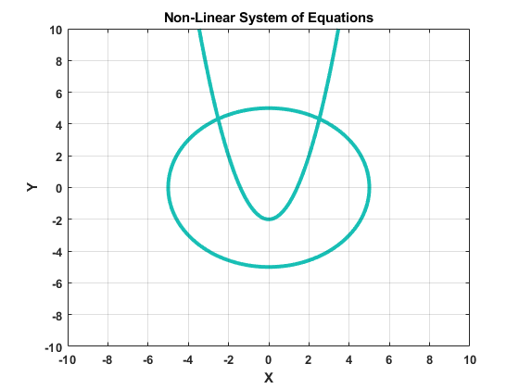



2. (Based on 3.40) A coating on a panel surface is cured by radiant energy from a heater. The temperature of the coating is determined by radiative and convective heat transfer processes. If the radiation is treated as diffuse and gray, the following nonlinear system of equations determine the unknowns Jh, Th, Jc and Tc: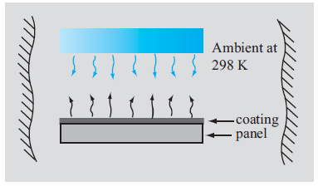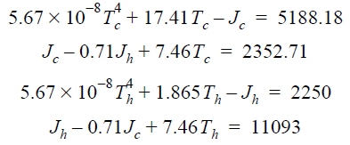

Use MATLAB’s built-in function fsolve to find values of Jh, Th, Jc and Tc that satisfy this system of equations. Use optimoptions to set the maximum iterations at 50 and the ‘StepTolerance’ to 1x10-9. For a starting value, use , and



3. Referring to Problem #2 above, if you were to solve that system of equations using Newton’s Method, you would need to determine the Jacobian matrix. In the space below, write down symbolically what each entry of the Jacobian matrix would be.

4. Solve the following system of equations using the Gauss elimination method:

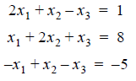

5. (Based on 4.32) The axial force in each of the 13-member pin-connected truss, shown in the figure, can be calculated by solving the following system of 13 equations: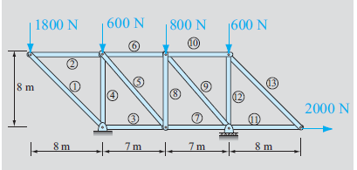



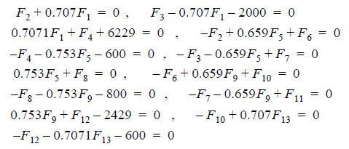

Use the function GaussPivot provided in the example for Lecture 8 to solve this system of equations.

**Numeric Answers:**

**Problem #1:**



**Problem #2:**

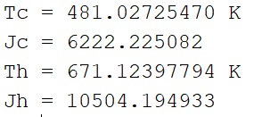

**Problem #3:**

No numeric answer.

**Problem #4:**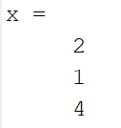

**Problem #5:**